

**Resilient Food Supply Chain Design**

Project Report

**Stanny Lemos**

NUID: 001388497

Email: [lemos.s@northeastern.edu](mailto:lemos.s@northeastern.edu)

Table of Contents

**1.0 Introduction** - 1 -

**1.1 Problem** - 1 -

**1.2 Metaheuristic Solution** - 1 -

**2.0 Literature Review** - 2 -

**2.1 Resilient food supply chain design: Modelling framework and metaheuristic solution approach** - 2 -

**2.2 A multi-objective sustainable hub location-scheduling problem for perishable food supply chain** - 2 -

**2.3 Sustainable supply chain network design** - 3 -

**2.4 Sustainable Agro-food supply chain design using two-stage hybrid multi-objective decision-making approach** - 3 -

**3.0 Model & Solution Approach** - 4 -

**4.0 Results and Analysis** - 6 -

**4.1 Results summary** - 6 -

**4.2 Analysis** - 6 -

**4.2.1 Varying demand range forecasts** - 6 -

**4.2.2 Varying Logistic Cost** - 8 -

**5.0 Future Work** - 11 -

**References:** **Error! Bookmark not defined.**

**List of Figures:**

Figure 3.1: FSC Model representation by graph - 4 -

Figure 4.2.a 1: Pareto Solutions - 7 -

Figure 5.1: Raw Material Supplier Quantity Matrix - 8 -

Figure 4.2.b 1: Pareto Solutions - 9 -

Figure 4.2.b 2: Raw Material Supplier Quantity Matrix - 10 -

# **1.0 Introduction**

## **1.1 Problem**

Global Foods is an industry leading food company which produces variety of different products which use number of raw materials. Currently, the procurement team does the procurement when they get demand forecast as per their demand planning team. The final products use raw materials in calculated quantity which are procured from supplier network. Global Foods is now faced with the proposition of fulfilling this forecasted demand while meeting the quality criteria within the defined timeline. The CEO feels that they procurement activity is not optimized, and they have more profitable endeavor with increased level of service.

Moreover, a food supply chain design that is resilient enough to ensure business operations continuity in the event of risks or disruptions is sought. in presence of supply disruption, the supply chain must be able to reconfigure its structure by resorting to alternative suppliers, with the purpose of minimizing the additional lead time this reconfiguration could involve. At the same time, the recourse to alternative suppliers should ensure that the market demand is fully satisfied and that the maximum supply chain profit can be generated.

## **1.2 Metaheuristic Solution**

After thorough research on activities of Global Foods, the optimization team proposed use of metaheuristics solution approach which uses combinatorial optimization in which a near optimal solution is sought over a discrete search-space. The rationale for this solution approach given by optimization team is that problem encountered by Global Foods is NP-hard, and company needs dynamic decisions wherein they need to evaluate optimal solution very frequently since the supplier market is very delicate and is disrupted for number of reasons namely environment, weather, seasonality. They primarily seek low incurred costs - Procurement and Logistics along with options of total time in the procurement activity – Lead time. A bi-objective model is formulated to minimize the total cost and lead time which will use a fast and elitist multi-objective genetic algorithm: NSGA-II[1]. Later the Procurement team has their own discretion to use their MCDM methods for them to evaluate their optimal choices determined by the model. This step provides the company with better control over lead time and raw material procurement which will eventually lead to increase profitability by directly reducing the total cost.

# **2.0 Literature Review**

## **2.1 Resilient food supply chain design: Modelling framework and metaheuristic solution approach**[2]

1. This paper addresses the Resilient Food Supply Chain Design (RFSCD) problem, which is the problem of designing a food supply chain that is resilient enough to ensure business operations continuity in the event of risks or disruptions.
2. Based on a graph theory representation of the food supply chain, this paper proposes a bi-objective mixed-integer programming formulation for this problem. The objectives are to (1) maximize the total profit over a one-year time span and (2) minimize the total lead time of the product along the supply chain. To solve the model, an Ant Colony Optimization (ACO) algorithm is presented.
3. The developed model is suitable for adoption for the design of a multi-product resilient food supply chain that makes use of a multiple sourcing policy to deal with unexpected fluctuations of market demand and disruptions in raw materials supply. The adapted ACO algorithm is tested on a case study, referring to the SC of readymade UHT tomato sauce, which is particularly vulnerable to such risks.
4. Future works can investigate the adaptation of the proposed algorithm to RFSCD problems in different contexts, thus taking into account further possible disruptions and risks.

## **2.2 A multi-objective sustainable hub location-scheduling problem for perishable food supply chain**[3]

1. This paper aims to model a novel and optimize the Scheduling and sequencing of the vehicles at the hubs for delivering perishable foods and taking into the account of perishability and freshness of products.
2. The problem is modeled as MILP with 3 prominent objectives, the total transportation costs, freshness and quality of foods at the time of delivery and the total carbon emissions of the vehicles to fulfill the sustainability desire of the environment, which makes it NP hard to solve by other traditional optimization methods, and numerical tests on two datasets confirmed that proposed NSGA-II is able to generate proper Pareto solutions.
3. A research direction is to deal with parameters of this model in uncertain environments, like robust optimization and fuzzy programming and integrating scheduling decisions with location-allocation decisions.

### **2.3 Sustainable supply chain network design**[4]

1. This paper incorporates all three dimensions of sustainability into supply chain network design encompassing economic, environmental and social objectives wherein the model aims to find the best possible configuration of supply chain that minimizes supply chain cost and greenhouse gas emissions and maximizes the network’s social impact.
2. The paper demonstrates trade-offs between economic, environmental and social objectives, and propose a set of innovative business models based on balanced solutions and how multiple sustainability objectives can be optimized.
3. The results on case study of the wine industry in Australia showed trade-offs between the objectives, yet more interestingly demonstrate how large is the gap between the existing supply chain configuration and the proposed scenarios in terms of supply chain cost and emissions.

### **2.4 Sustainable Agro-food supply chain design using two-stage hybrid multi-objective decision-making approach**[5]

1. Sustainability of Agro-food supply chains is the subject of greater interest from consumers, firms, governmental organizations and academia as the environment continues to deteriorate. One of the most critical factors influencing the sustainability of an agro-food supply chain is its network design.
2. A novel two-stage hybrid solution methodology is proposed for the model. The first stage uses MCDM based on Analytic Hierarchy Process (AHP) method and the Ordered Weighted Averaging (OWA) aggregation method. The result obtained in the first stage is used in the second stage to develop a multi-objective mathematical model to optimize the design of the supply chain network.
3. The author states that this approach allows the simultaneous consideration of all three dimensions of sustainability including carbon footprint, water footprint, number of jobs created and the total cost of the supply chain design

# **3.0 Model & Solution Approach**

This model is simplified for this project but has successfully managed to encompassed number of variable factors and real-life scenarios into the account. The data used for the model is initially randomly generated and then used for the model.

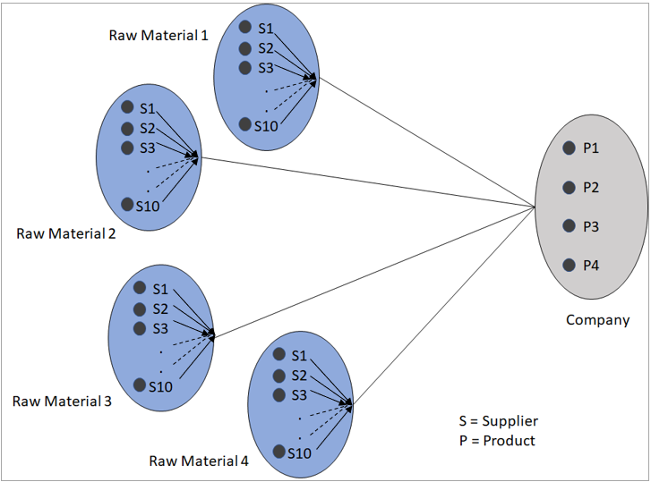

Figure 3.1: FSC Model representation by graph

1. There are four different products produced by the company. The demand planning team has its ‘range forecast’ for them. These range is encompassed in the ‘VarMin(1:4)’ and ‘VarMax(1:4)’ of the problem definition.
2. These four different end products use four different raw materials in varying formulation.
3. All these end products use all the four raw materials, and the supply chain team then gives the final raw material formulation required to the procurement team, which is basically the sum of each material formulation required for each product.
4. On the supplier side, ten different suppliers are considered in the company network.
5. The suppliers supply these four materials at different rates and have different lead time for each material. They are modelled in ‘rmcost’ and ‘rmlt’ matrix respectively.
6. The suppliers are spread across and their distance to company is given in ‘rmdm’ matrix.
7. The suppliers have limited capacity for each of the material they supply, modelled in ‘rmcap’ matrix.
8. The company incurs fixed cost ‘sfc’ for material procurement line it uses. The fixed cost accounts for many fixed costs for company namely administrative and ordering costs.
9. For each material, the ‘test’ function evaluates random metaheuristic combination of supplier network the algorithm generates, and gives two outputs, ‘RM’ and ‘RMSQ’.
10. The ‘RM’ has three elements ‘[RMC RMLT RMTD]’. RMC stores the calculated cost of procurement, RMLT stores the lead time, RMTD stores the total distance for which the logistics would be needed.
11. The ‘RMSQ’ matrix stores the procurement quantity for each material and supplier for every combination of network.
12. The ‘Cost’ function takes the input of range forecast and gives two output ‘z’ and ‘RMSQC’.
13. ‘z’ has two minimization objective functions, z1 as cost and z2 as max lead time for procurement and delivery activity.
14. ‘RMSQC’ is the final procurement quantity matrix from each supplier.
15. The NSGA-II algorithm is then evaluated the system for number of iterations, ‘MaxIt’ with various other standard parameters which are tuned for the problem setting.[6]

# **4.0 Results and Analysis**

## **4.1 Results summary**

1. The model, for the given demand and logistic cost has namely two main outputs
2. The Pareto solutions, i.e. the minimum cost vs lead-time frontier.
3. The RMSQC matrix, which tells us how much quantity of material X to procure from supplier Y for every solution on the pareto frontier.
4. They model with 10 supplier and 4 materials that need to be procured gives pareto solutions in range of 5-10 which is desirable for further MCDM methods to pick optimal solution for the company.
5. It is believed the model will develop more pareto solutions for larger number of suppliers and materials dataset.
6. With the figures below we can see that if the company needs less cost it needs to have higher lead-time and vice versa which is the actual real-life scenario. One needs to wait more to enjoy less cost.

## **4.2 Analysis**

### **4.2.1 Varying demand range forecasts**

Range forecast are great tool a forecaster can use. It naturally incorporates the uncertainty which can not be modelled by point forecasts. Hence, the solution model makes use range forecast as one of the variables.

Also, it is possible to input point forecasts into the model, if one needs to. The VarMax and VarMin limits would be the same for point a forecast demand.

The model has performed satisfactorily under various input demands which are shown below.

A sample solution for range forecast is below.

#### **4.2.1.a Variables:**

Demand: Product 1 – Min 470 and Max 490

Product 2 – Min 490 and Max 530

Product 3 – Min 440 and Max 490

Product 4 – Min 460 and Max 490

Logistic Cost: Min $1 to Max $5

Output: X: Profit in dollars

Y: Lead time in days

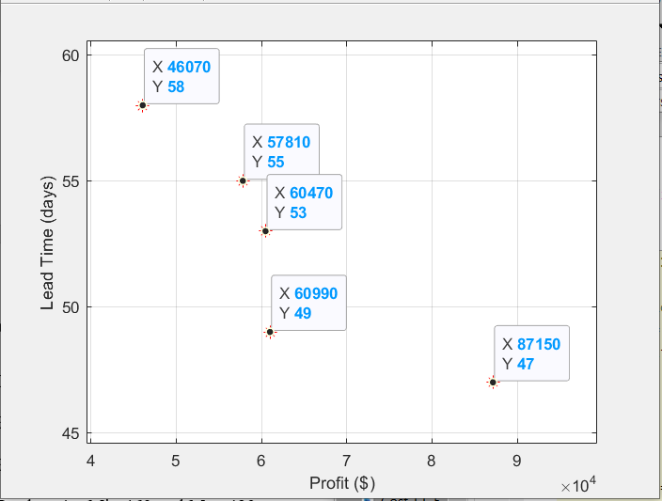

Figure 4.2.a 1: Pareto Solutions

For the solution, frontier 1, we get five RMSQC matrix: the supplier purchase quantity. A sample is shown below. Here we can see that we need to purchase materials in following quantity

1. Supplier 6
   1. Material 1 – Quantity 108
   2. Material 3 – Quantity 55
   3. Material 4 – Quantity 122
2. Supplier 7
   1. Material 2 – Quantity 66
3. Supplier 8
   1. Material 4 – Quantity 120

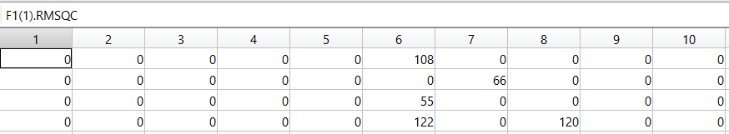

Figure 5.2: Raw Material Supplier Quantity Matrix

### **4.2.2 Varying Logistic Cost**

Logistics costs per mile are not fixed and depend a variety of factors namely fuel costs, vehicle capacity, the labor market for commercial drivers (which is highly impacted in COVID-19 pandemic), demand for freight. Though through USA the average cost per mile is 1.4$ per mile it can go high as 4$ per mile[7], i.e. about 200% increase above average per mile cost. Though they are less considered for high margin products, they make huge difference under wafer thin margin business like food and grocery especially when you need to procure from considerable amount of distance. Hence Logistic cost is built in as a variable in the system and be determined from Freight bidding platforms[8] online where bidding for freight carrier takes place.

#### **4.2.1.b Variables:**

Demand: Product 1 – Min 42 and Max 48

Product 2 – Min 80 and Max 95

Product 3 – Min 94 and Max 154

Product 4 – Min 250 and Max 214

Logistic Cost: Fixed : 1.4$ per mile

Output: X: Profit in dollars

Y: Lead time in days

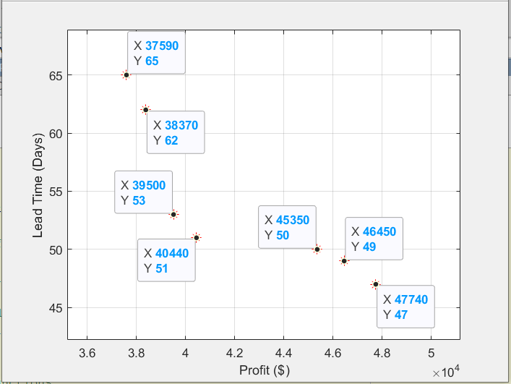

Figure 4.2.b 3: Pareto Solutions

For the solution, frontier 1, we get seven RMSQC matrix: the supplier purchase quantity. A sample is shown below. Here we can see that we need to purchase materials in following quantity

1. Supplier 4
   1. Material 3 – Quantity 42
   2. Material 4 – Quantity 122
2. Supplier 5
   1. Material 1 – Quantity 105
3. Supplier 9
   1. Material 9 – Quantity 54
4. Supplier 10
   1. Material 4 – Quantity 137

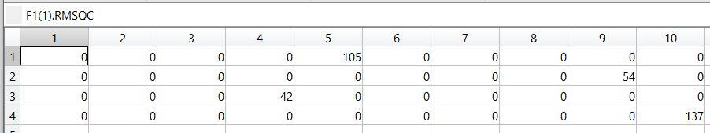

Figure 4.2.b 4: Raw Material Supplier Quantity Matrix

# **5.0 Future Work**

Future works can investigate the adaptation of the proposed algorithm and model to RFSCD problems in different contexts, thus considering further possible disruptions and risks. The model needs to incorporate various scenarios and needs to be simulated for outcomes as cost of extra supplier in the network since that extra line can be utilized when one supplier has outage.

The model needs to be developed for multi echelon systems like supplier, production, and delivery which brings dynamic complexity into the systems.

The model also needs to differentiate between critical and non-critical raw materials and give preferences high margin products with high product velocity.

# **6.0 References**

[1] K. Deb, A. Pratap, S. Agarwal, and T. Meyarivan, “A fast and elitist multiobjective genetic algorithm: NSGA-II,” *IEEE Trans. Evol. Comput.*, vol. 6, no. 2, pp. 182–197, Apr. 2002, doi: 10.1109/4235.996017.

[2] E. Bottani, T. Murino, M. Schiavo, and R. Akkerman, “Resilient food supply chain design: Modelling framework and metaheuristic solution approach,” *Comput. Ind. Eng.*, vol. 135, pp. 177–198, Sep. 2019, doi: 10.1016/j.cie.2019.05.011.

[3] M. Musavi and A. Bozorgi-Amiri, “A multi-objective sustainable hub location-scheduling problem for perishable food supply chain,” *Comput. Ind. Eng.*, vol. 113, pp. 766–778, Nov. 2017, doi: 10.1016/j.cie.2017.07.039.

[4] M. Varsei and S. Polyakovskiy, “Sustainable supply chain network design: A case of the wine industry in Australia,” *Omega*, vol. 66, pp. 236–247, Jan. 2017, doi: 10.1016/j.omega.2015.11.009.

[5] H. Allaoui, Y. Guo, A. Choudhary, and J. Bloemhof, “Sustainable agro-food supply chain design using two-stage hybrid multi-objective decision-making approach,” *Comput. Oper. Res.*, vol. 89, pp. 369–384, Jan. 2018, doi: 10.1016/j.cor.2016.10.012.

[6] Yarpiz, “NSGA-II in MATLAB,” *Yarpiz*, Sep. 01, 2015. https://yarpiz.com/56/ypea120-nsga2 (accessed Apr. 25, 2020).

[7] “Truck Freight Rates.” https://truckerpath.com/blog/truck-freight-rates/ (accessed Apr. 25, 2020).

[8] “Freight Bidding Platforms: Make Your Life Easier With These 5,” *Transportation Management Company | Cerasis*, May 23, 2014. https://cerasis.com/freight-bidding-platforms/ (accessed Apr. 25, 2020).